TARGET BUSINESS CASE

Problem Statement:
Assuming you are a data analyst/ scientist at Target, you have been assigned the task of analyzing the given dataset to extract valuable insights and provide actionable recommendations.

- Import the dataset and do usual exploratory analysis steps like checking the structure & characteristics of the dataset:

- Data type of all columns in the "customers" table.

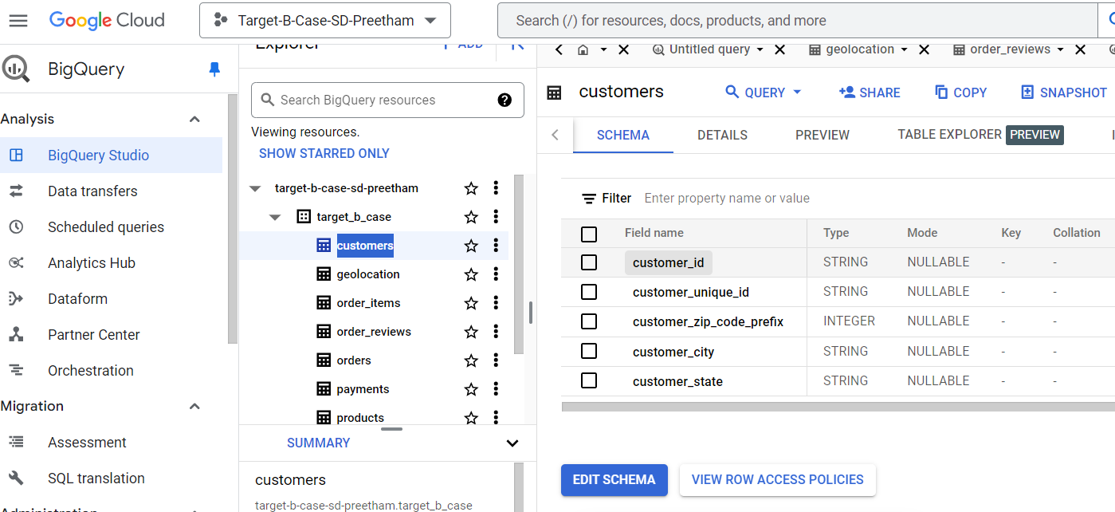

COLUMN DATA TYPE
customer_id | STRING
customer_unique_id | STRING
customer_zip_code_prefix | INTEGER
customer_city | STRING
customer_state | STRING

- Get the time range between which the orders were placed.

SELECT min(order_purchase_timestamp) as lower_limit,
max(order_purchase_timestamp) as upper_limit
FROM `target-b-case-sd-preetham.target_b_case.orders`

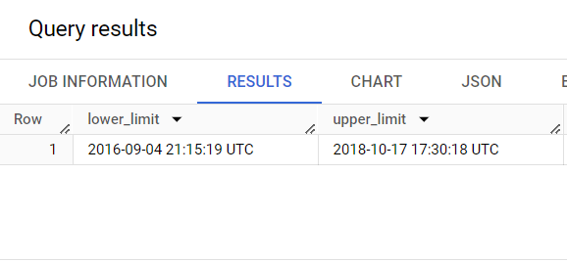

3. Count the Cities & States of customers who ordered during the given period.

SELECT COUNT(DISTINCT customer_city) AS City,
COUNT(DISTINCT customer_state) AS State
FROM `target-b-case-sd-preetham.target_b_case.orders` AS o JOIN
`target-b-case-sd-preetham.target_b_case.customers` AS c
ON o.customer_id = c.customer_id;

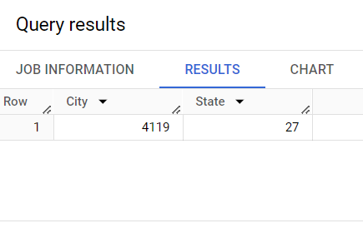

- In-depth Exploration:

- Is there a growing trend in the no. of orders placed over the past years?

SELECT
EXTRACT(YEAR FROM order_purchase_timestamp) AS Year,
COUNT(DISTINCT order_id) AS total_orders
FROM `target-b-case-sd-preetham.target_b_case.orders`
GROUP BY Year
ORDER BY Year;

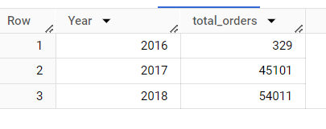
Yes, there is a growing trend with the progression of years.

- Can we see some kind of monthly seasonality in terms of the no. of orders being placed?

SELECT
EXTRACT(YEAR FROM order_purchase_timestamp) AS Year,
EXTRACT(MONTH FROM order_purchase_timestamp) AS Month,
COUNT(DISTINCT order_id) AS total_orders
FROM `target-b-case-sd-preetham.target_b_case.orders`
GROUP BY Year, Month
ORDER BY Year, Month;

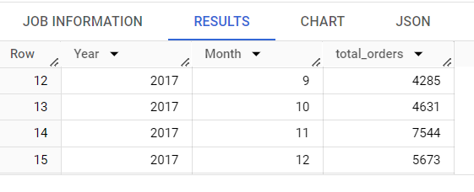
Yes, there is a seasonality being observed in the number of orders placed. Certain months like November 2017, January 2018 have witnessed a high surge in the number of orders made.

Actionable Insights and Recommendations
Maximize on Seasonal Promotions
Insight: Order volumes peak in some months and fall in some suggesting seasonal data effects.
Recommendation: Use historical sales data and implement targeted marketing campaigns and promotions during peak shopping months to maximize sales.

- During what time of the day, do the Brazilian customers mostly place their orders? (Dawn, Morning, Afternoon or Night)
  - 0-6 hrs : Dawn
  - 7-12 hrs : Mornings
  - 13-18 hrs : Afternoon
  - 19-23 hrs : Night

SELECT CASE
WHEN (EXTRACT(HOUR FROM order_purchase_timestamp)) BETWEEN 0 AND 6 THEN 'Dawn'
WHEN (EXTRACT(HOUR FROM order_purchase_timestamp)) BETWEEN 7 AND 12 THEN 'Morning'
WHEN (EXTRACT(HOUR FROM order_purchase_timestamp)) BETWEEN 13 AND 18 THEN 'Afternoon'
ELSE 'Evening' END as Day_Phase, COUNT(DISTINCT order_id) AS order_count
FROM `target-b-case-sd-preetham.target_b_case.orders`
GROUP BY Day_phase
ORDER BY order_count DESC ;

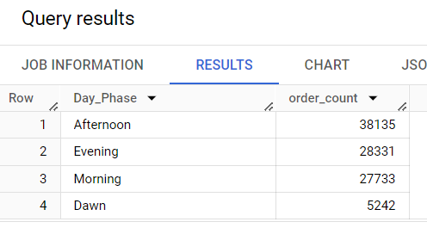

It is observed that most of the orders happen in the afternoon.

Evolution of E-commerce orders in the Brazil region:

- Get the month on month no. of orders placed in each state.

SELECT
customers.customer_state,
EXTRACT(YEAR FROM orders.order_purchase_timestamp) AS year,
EXTRACT(MONTH FROM orders.order_purchase_timestamp) AS month,
COUNT(orders.order_id) AS total_orders
FROM `target-b-case-sd-preetham.target_b_case.orders` AS orders
JOIN `target-b-case-sd-preetham.target_b_case.customers` AS customers
ON orders.customer_id = customers.customer_id
GROUP BY customers.customer_state, year, month
ORDER BY year, month,customers.customer_state;

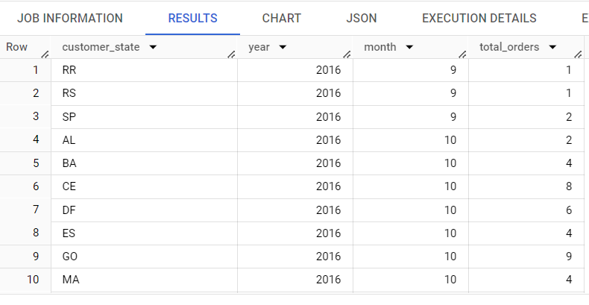

- How are the customers distributed across all the states?

SELECT customer_state, COUNT(DISTINCT customer_id) as Population
FROM `target-b-case-sd-preetham.target_b_case.customers`
GROUP BY customer_state
ORDER BY Population desc;

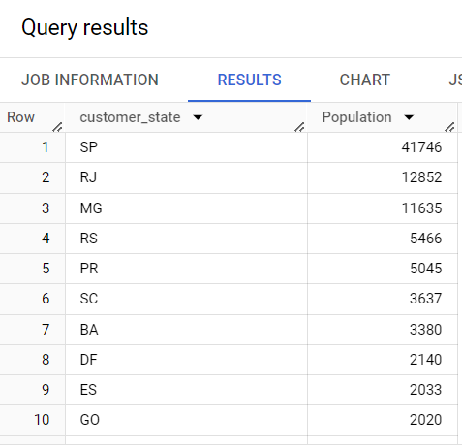
Impact on Economy: Analyze the money movement by e-commerce by looking at order prices, freight and others.

- Get the % increase in the cost of orders from year 2017 to 2018 (include months between Jan to Aug only).
You can use the "payment_value" column in the payments table to get the cost of orders.
WITH payments_2017 AS (
SELECT
ROUND(SUM(p.payment_value),2) AS total_payment_2017
FROM
`target-b-case-sd-preetham.target_b_case.payments` AS p
JOIN
`target-b-case-sd-preetham.target_b_case.orders` AS o
ON p.order_id = o.order_id
WHERE
EXTRACT(YEAR FROM o.order_purchase_timestamp) = 2017
AND EXTRACT(MONTH FROM o.order_purchase_timestamp) BETWEEN 1 AND 8
),
payments_2018 AS (
SELECT
ROUND(SUM(p.payment_value),2) AS total_payment_2018
FROM
`target-b-case-sd-preetham.target_b_case.payments` AS p
JOIN
`target-b-case-sd-preetham.target_b_case.orders` AS o
ON p.order_id = o.order_id
WHERE
EXTRACT(YEAR FROM o.order_purchase_timestamp) = 2018
AND EXTRACT(MONTH FROM o.order_purchase_timestamp) BETWEEN 1 AND 8
)

SELECT
total_payment_2018,
total_payment_2017,
ROUND(((total_payment_2018 - total_payment_2017) / total_payment_2017),2) * 100 AS percentage_increase
FROM
payments_2017, payments_2018;

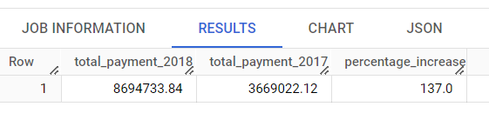
Monitor pricing strategies for increment in sales.
Insight: The percentage increase in cost of orders from 2017 to 2018 suggests sensitivity to price fluctuation.
Recommendation: Implement competitive pricing strategies considering the level of price sensitivity of customers.

2.Calculate the Total & Average value of order price for each state.

SELECT
c.customer_state, ROUND(SUM(oi.price),2) as Total, ROUND(AVG(oi.price),2) as Average
FROM `target-b-case-sd-preetham.target_b_case.order_items` oi JOIN
`target-b-case-sd-preetham.target_b_case.orders` o
ON o.order_id = oi.order_id
JOIN `target-b-case-sd-preetham.target_b_case.customers` c
ON o.customer_id = c.customer_id
GROUP BY c.customer_state
ORDER BY Total desc;
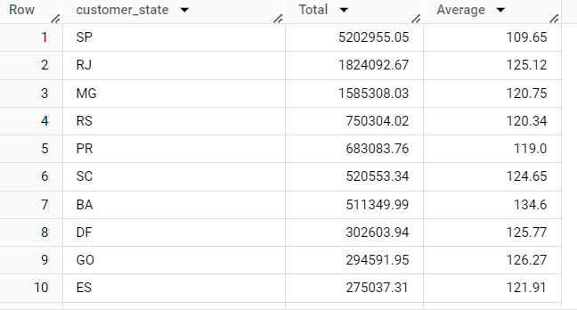

3.Calculate the Total & Average value of order freight for each state.

SELECT
c.customer_state, ROUND(SUM(oi.freight_value),2) as Total, ROUND(AVG(oi.freight_value),2) as Average
FROM `target-b-case-sd-preetham.target_b_case.order_items` oi JOIN
`target-b-case-sd-preetham.target_b_case.orders` o
ON o.order_id = oi.order_id
JOIN `target-b-case-sd-preetham.target_b_case.customers` c
ON o.customer_id = c.customer_id
GROUP BY c.customer_state
ORDER BY Total desc;

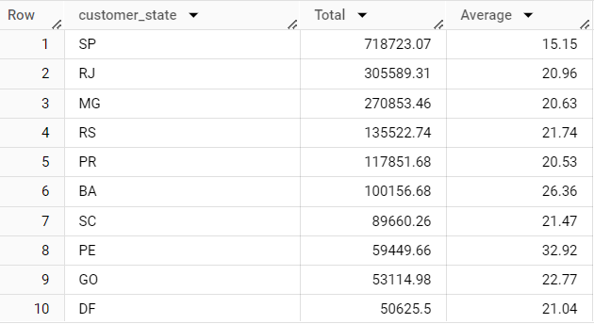

Actionable Insights and Recommendations

Insight: Certain states have consistently low order volumes or higher freight costs, indicating potential inefficiencies in inventory distribution.

Recommendation: Reassess inventory allocation and distribution strategies to ensure popular products are readily available in regions with high demand.

Analysis based on sales, freight and delivery time.

1. Find the no. of days taken to deliver each order from the order’s purchase date as delivery time.

SELECT
order_id,
DATE_DIFF(order_delivered_customer_date, order_purchase_timestamp, DAY) AS time_to_deliver,
DATE_DIFF(order_delivered_customer_date, order_estimated_delivery_date, DAY) AS diff_estimated_delivery
FROM
`target-b-case-sd-preetham.target_b_case.orders`;

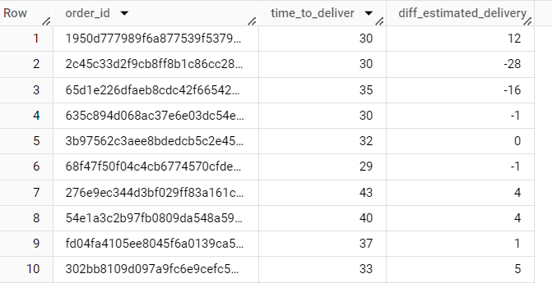

2.Find out the top 5 states with the highest & lowest average freight value.

WITH avg_freight_statewise AS (
SELECT c.customer_state, ROUND(AVG(oi.freight_value),2) AS Average_Freight
FROM `target-b-case-sd-preetham.target_b_case.customers` c JOIN
`target-b-case-sd-preetham.target_b_case.orders` o
ON c.customer_id = o.customer_id
JOIN `target-b-case-sd-preetham.target_b_case.order_items` oi
ON o.order_id = oi.order_id
GROUP BY c.customer_state

)

Lowest 5 states

SELECT customer_state, Average_Freight
FROM `avg_freight_statewise`
ORDER BY Average_Freight
LIMIT 5;
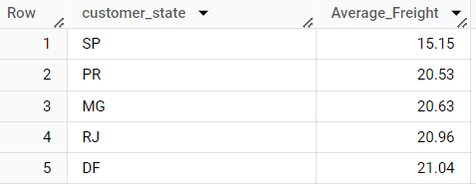

Highest 5 states

SELECT customer_state, Average_Freight
FROM `avg_freight_statewise`
ORDER BY Average_Freight desc
LIMIT 5;

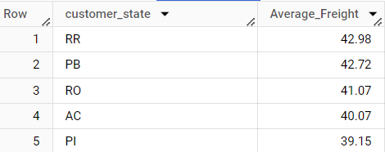

3. Find out the top 5 states with the highest & lowest average delivery time.

WITH avg_delivery_time AS (
SELECT c.customer_state, ROUND(AVG(DATE_DIFF(o.order_delivered_customer_date,o.order_purchase_timestamp ,DAY)),2) AS delivery_time
FROM `target-b-case-sd-preetham.target_b_case.customers` c JOIN
`target-b-case-sd-preetham.target_b_case.orders` o
ON c.customer_id = o.customer_id

GROUP BY c.customer_state

)

Lowest 5
SELECT customer_state,delivery_time
FROM `avg_delivery_time`
ORDER BY delivery_time
LIMIT 5;

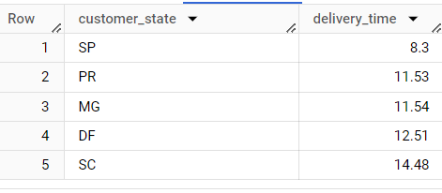

Highest 5
SELECT customer_state,delivery_time
FROM `avg_delivery_time`
ORDER BY delivery_time desc
LIMIT 5;

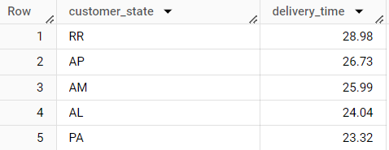

Actionable Insights and Recommendations
Improve Delivery Speed
- Insight: Analysis reveals delivery times differ across states, with some states experiencing longer delays.
- Recommendation: Enhance logistics partnerships to streamline the delivery process.

Find out the top 5 states where the order delivery is really fast as compared to the estimated date of delivery.

WITH avg_fast_delivery AS (
SELECT c.customer_state,ROUND(AVG(DATE_DIFF(o.order_estimated_delivery_date,o.order_delivered_customer_date,DAY)),2) AS Average_Fast_Delivery
FROM `target-b-case-sd-preetham.target_b_case.customers` c JOIN
`target-b-case-sd-preetham.target_b_case.orders` o
ON c.customer_id = o.customer_id
WHERE o.order_estimated_delivery_date > o.order_delivered_customer_date
GROUP BY c.customer_state

)
SELECT customer_state, Average_Fast_Delivery
FROM `avg_fast_delivery`
ORDER BY Average_Fast_Delivery
LIMIT 5;

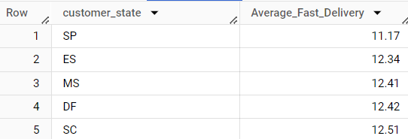

Analysis based on the payments:

- Find the month on month no. of orders placed using different payment types.

SELECT EXTRACT(YEAR from order_purchase_timestamp) as YEAR,
EXTRACT(MONTH from order_purchase_timestamp) as MONTH,
payments.payment_type,
COUNT(DISTINCT payments.order_id) as total
FROM `target-b-case-sd-preetham.target_b_case.orders` AS orders JOIN
`target-b-case-sd-preetham.target_b_case.payments` AS payments
ON orders.order_id = payments.order_id
GROUP BY YEAR, MONTH ,payments.payment_type
ORDER BY YEAR, MONTH, payments.payment_type;

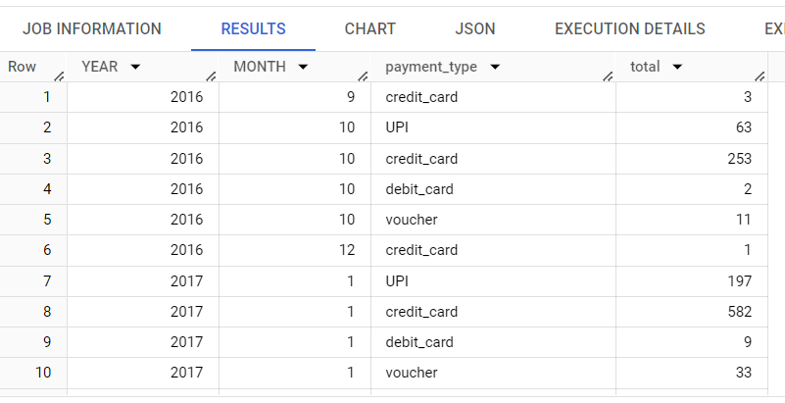

2.Find the no. of orders placed on the basis of the payment installments that have been paid.

SELECT
payments.payment_installments as Payment_Installment,
COUNT(DISTINCT payments.order_id) as total
FROM `target-b-case-sd-preetham.target_b_case.orders` AS orders JOIN
`target-b-case-sd-preetham.target_b_case.payments` AS payments
ON payments.order_id =orders.order_id
GROUP BY payments.payment_installments
ORDER BY total desc;

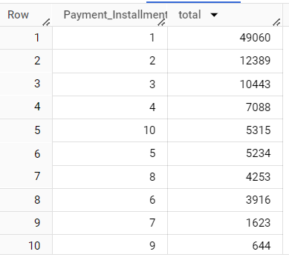

Tailor Payment Options
Insight: Payment modes trends reflect that there are specific preferences of a customer for specific types of payments and installment options for different customer segments.
Recommendation: Flexible payment options-certainlywould likely appeal to customers with a wide range of different needs, thereby enhancing customer satisfaction and converting them into higher-income segment customers.

Conclusion

These actionable insights and recommendations implemented may greatly enhance the operational efficiency of Target in Brazil and improve its performance in terms of customer satisfaction. Through the use of data-driven strategies, Target will be able to meet better the needs of the target customers, thereby enhancing sales and even more so ensuring brand loyalty in a competitive environment.

